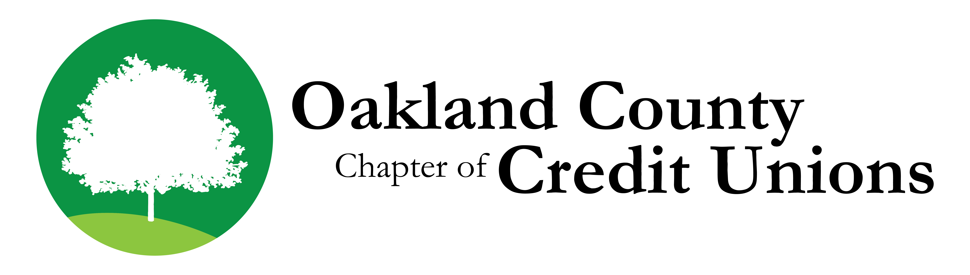


Oakland County Chapter of Credit Unions
Lansing Advocacy Day
Wednesday, May 22, 2019

Attention: Credit Union Managers, Staff and Volunteers – Join Us!

The Oakland County Chapter of Credit Unions will host the Annual “Lansing Advocacy Day” on Wednesday, May 22, 2019. This is your opportunity to:

- Lunch and network informally with Oakland County State Senators and Representatives.
- Learn about important issues affecting credit unions in our state legislature. An update by MCUL will take place on the bus.
- Provide a credit union perspective to our elected representatives.
- Meet and interact with fellow credit union leaders.
- Visit sessions in the Senate and House chambers.

The November Election resulted in many changes to our Oakland County legislative districts. 13 out of 19 districts experienced a change. It is imperative with all these new legislators in office that we have a good turnout at our “Lansing Advocacy Day” in order to educate them on Credit Union issues and build relationships with these new Lansing leaders.
With many new lawmakers coming to our State Capitol, there has never been a more crucial time for you to continue your support of Michigan’s credit union movement.
The Oakland County Chapter has chartered a bus to make the day as enjoyable and convenient as possible for all those who attend. The bus will drop participants off in back of the State Capitol Building. From the same drop off location, it will be back on the road at 2:30 p.m.--estimated time back to Oakland County 4 p.m.

Please RSVP by May 15, 2019
There is no cost for this event!
To register please provide the following information by e-mail to Cecilia Palen at Genisys Credit Union cpalen@genisyscu.org
Please provide an email for each participant so that we can send issues & trip information prior to the event.

Participant(s):
_____________________________ ________________________________/___________________ _________
Name Email Address Phone - Cell Preferred Bus Stop #

_____________________________ ________________________________/___________________ _________
Name Email Address Phone - Cell Preferred Bus Stop #

_____________________________ ________________________________/___________________ _________
Name Email Address Phone - Cell Preferred Bus Stop #

Credit Union: __________________________________________ Contact Name: __________________________________
CU Contact Phone # ______________________ Ext._______
Bus pick-up will be at two stops:
#1 – Oakland County Airport, 6500 Highland Road (M59), Waterford, pick-up at 9:00 a.m.
#2 – Rural King, 10400 Highland Road (M59), Hartland, pick-up at 9:30 a.m.
If you Plan on attending but not riding the bus, please indicate by writing “Self” above.

